* AndroidManifest.xml

*<?***xml version="1.0" encoding="utf-8"***?>*<**manifest xmlns:android="http://schemas.android.com/apk/res/android"  
 package="com.example.amit.rockpaperscissor"**>  
  
 <**uses-permission android:name="android.permission.WRITE_EXTERNAL_STORAGE"** />  
 <**uses-permission android:name="android.permission.READ_EXTERNAL_STORAGE"** />  
 <**uses-permission android:name="android.permission.VIBRATE"** />  
  
 <**application  
 android:allowBackup="true"  
 android:icon="@mipmap/rps_round_wh"  
 android:label="@string/app_name"  
 android:supportsRtl="true"  
 android:theme="@style/AppTheme"**>  
 <**activity  
 android:name=".MainActivity"  
 android:screenOrientation="portrait"** />  
 <**activity  
 android:name=".RPSGraphic"  
 android:screenOrientation="portrait"** />  
 <**activity  
 android:name=".HomeScreen"  
 android:exported="true"  
 android:screenOrientation="portrait"**>  
 <**intent-filter**>  
 <**action android:name="android.intent.action.MAIN"** />  
  
 <**category android:name="android.intent.category.LAUNCHER"** />  
 </**intent-filter**>  
 </**activity**>  
 <**activity android:name=".result"** />  
 </**application**>  
  
</**manifest**>

* Java File
* HomeScreen.java

**package** com.example.amit.rockpaperscissor;  
  
**import** android.app.Activity;  
**import** android.content.Intent;  
**import** android.os.Bundle;  
**import** android.view.Menu;  
**import** android.view.View;  
**import** android.widget.Button;  
  
**import** java.io.FileOutputStream;  
  
**public class** HomeScreen **extends** Activity **implements** View.OnClickListener{  
 Button **btnSimple**=**null**,**btnGraph**=**null**;  
  
 FileOutputStream **f** = **null**;  
 String **path** = **"test.txt"**;  
  
 @Override  
 **protected void** onCreate(Bundle savedInstanceState) {  
 **super**.onCreate(savedInstanceState);  
 setContentView(R.layout.***activity_home_screen***);  
  
 **btnSimple** = (Button)findViewById(R.id.***btnSimple***);  
 **btnGraph** = (Button)findViewById(R.id.***btnGraph***);  
  
 **btnSimple**.setOnClickListener(**this**);  
 **btnGraph**.setOnClickListener(**this**);  
 }  
  
 */* @Override  
 public boolean onCreateOptionsMenu(Menu menu) {  
 getMenuInflater().inflate(R.menu.menu_bar,menu);  
 return super.onCreateOptionsMenu(menu);  
 }  
*/* @Override  
 **public void** onClick(View view) {  
 Intent i;  
 **if** (view.getId() == R.id.***btnSimple***){  
 i = **new** Intent(**this**, MainActivity.**class**);  
 startActivity(i);  
 */*try {  
 f=new FileOutputStream(path);  
 byte[] buff = "This will be written in test.txt".getBytes();  
 f.write(buff,0,buff.length);  
 f.close();  
 if(f.createNewFile())  
 Toast.makeText(this, "New File created", Toast.LENGTH_SHORT).show();  
 else  
 Toast.makeText(this, "File not created", Toast.LENGTH_SHORT).show();  
 } catch (IOException e) {  
 Toast.makeText(this, "File creation error", Toast.LENGTH_SHORT).show();  
 }*/* }  
 **else** {  
 i = **new** Intent(**this**, RPSGraphic.**class**);  
 startActivity(i);  
 }  
  
 }  
}

* MainActivity.java

**package** com.example.amit.rockpaperscissor;  
  
**import** android.app.Activity;  
**import** android.content.Context;  
**import** android.content.Intent;  
**import** android.os.Bundle;  
**import** android.os.Handler;  
**import** android.os.Vibrator;  
**import** android.view.View;  
**import** android.widget.Button;  
**import** android.widget.TextView;  
**import** android.widget.Toast;  
  
**import** java.util.Random;  
  
**public class** MainActivity **extends** Activity **implements** View.OnClickListener{  
  
 TextView **lblPChoice**=**null**,**lblPC**=**null**,**lblRes**=**null**;  
 Button **btnRock**=**null**,**btnScissor**=**null**,**btnPaper**=**null**;  
 **int pcnt** = 0,**acnt** = 0,**dcnt** = 0,**total** = 0;  
  
  
 **private** Integer **seconds** = 31; *//THIS WILL RUN FOR 30 SECONDS* **private boolean stopTimer** = **false**;  
 TextView **lblTime** = **null**;  
  
 @Override  
 **protected void** onCreate(Bundle savedInstanceState) {  
 **super**.onCreate(savedInstanceState);  
 setContentView(R.layout.***activity_main***);  
 setTitle(**"SimpleMode"**);  
  
 **lblPC** = (TextView)findViewById(R.id.***lblPC***);  
 **lblPChoice** = (TextView)findViewById(R.id.***lblPChoice***);  
 **lblRes** = (TextView)findViewById(R.id.***lblRes***);  
  
 **btnRock** = (Button)findViewById(R.id.***btnRock***);  
 **btnPaper** = (Button)findViewById(R.id.***btnPaper***);  
 **btnScissor** = (Button)findViewById(R.id.***btnScissor***);  
  
 **btnRock**.setOnClickListener(**this**);  
 **btnPaper**.setOnClickListener(**this**);  
 **btnScissor**.setOnClickListener(**this**);  
  
 **lblTime** = (TextView) findViewById(R.id.***lblTime***);  
 timer();  
 }  
  
 **private void** timer() {  
 **final** Handler handler = **new** Handler();  
 handler.post(**new** Runnable() {  
  
 @Override  
 **public void** run() {  
 **seconds**--;  
 **if** (**seconds** == 0) {  
 *// DO SOMETHING WHEN TIMES UP* **stopTimer** = **true**;  
 }  
 **if**(**stopTimer** == **false**) {  
 handler.postDelayed(**this**, 1000);  
 **lblTime**.setText(**seconds**.toString());  
 */// Toast.makeText(MainActivity.this,seconds.toString(), Toast.LENGTH_SHORT).show();* }**else** {  
 *//passing score to next activity* Intent i = **new** Intent(MainActivity.**this**,result.**class**);  
 i.putExtra(**"Score"**,**lblPC**.getText().toString());  
 startActivity(i);  
 finish();  
 }  
 }  
  
 });  
 }  
 @Override  
 **public void** onClick(View view) {  
 String elements[]={**"ROCK"**,**"PAPER"**,**"SCISSOR"**};  
 **int** index = **new** Random().nextInt(elements.**length**);  
 String ran = (elements[index]);  
 **lblPChoice**.setText(ran);  
 **total**++;  
 **switch** (view.getId()){  
 **case** R.id.***btnRock***:  
 **if**(ran.equalsIgnoreCase(**"ROCK"**))draw();  
 **else if**(ran.equalsIgnoreCase(**"PAPER"**))awon();  
 **else if**(ran.equalsIgnoreCase(**"SCISSOR"**))pwon();  
 **break**;  
 **case** R.id.***btnPaper***:  
 **if**(ran.equalsIgnoreCase(**"PAPER"**))draw();  
 **else if**(ran.equalsIgnoreCase(**"SCISSOR"**))awon();  
 **else if**(ran.equalsIgnoreCase(**"ROCK"**))pwon();  
 **break**;  
 **case** R.id.***btnScissor***:  
 **if**(ran.equalsIgnoreCase(**"SCISSOR"**))draw();  
 **else if**(ran.equalsIgnoreCase(**"ROCK"**))awon();  
 **else if**(ran.equalsIgnoreCase(**"PAPER"**))pwon();  
 **break**;  
 }  
 }  
 **void** draw() {  
 **lblRes**.setText(**"Match Draw \uD83D\uDE10"**);  
 **dcnt**++;  
 **lblPC**.setText(**"----- SCORE ----\n\nPlayer : "**+**pcnt**+**"\n\nComputer : "**+**acnt**+**"\n\nDraw : "**+**dcnt**+**"\n\nTotal : "**+**total**);  
 }  
 **void** pwon() {  
 **lblRes**.setText(**"Player won"**);  
 **pcnt**++;  
 **lblPC**.setText(**"----- SCORE ----\n\nPlayer : "**+**pcnt**+**" \uD83D\uDE0A\n\nComputer : "**+**acnt**+**"\n\nDraw : "**+**dcnt**+**"\n\nTotal : "**+**total**);  
 }  
 **void** awon() {  
 **lblRes**.setText(**"Computer won"**);  
 **acnt**++;  
 **lblPC**.setText(**"----- SCORE ----\n\nPlayer : "**+**pcnt**+**"\n\nComputer : "**+**acnt**+**" \uD83D\uDE0A\n\nDraw : "**+**dcnt**+**"\n\nTotal : "**+**total**);  
 Vibrator vibrator = (Vibrator) **this**.getSystemService(Context.***VIBRATOR_SERVICE***);  
 vibrator.vibrate(100);  
 }  
}

* Result.java

**package** com.example.amit.rockpaperscissor;  
  
**import** android.app.Activity;  
**import** android.content.Intent;  
**import** android.os.Bundle;  
**import** android.view.View;  
**import** android.widget.ImageView;  
**import** android.widget.TextView;  
  
**public class** result **extends** Activity **implements** View.OnClickListener {  
  
 TextView **lblResFinal** = **null**;  
 ImageView **btnPlay** = **null**;  
 @Override  
 **protected void** onCreate(Bundle savedInstanceState) {  
 **super**.onCreate(savedInstanceState);  
 setContentView(R.layout.***activity_result***);  
  
 **lblResFinal** = (TextView) findViewById(R.id.***lblResFinal***);  
 **btnPlay** = (ImageView) findViewById(R.id.***btnPlay***);  
 **btnPlay**.setOnClickListener(**this**);  
  
 Intent i = getIntent();  
 String result = i.getExtras().getString(**"Score"**);  
 **lblResFinal**.setText(result);  
 }  
 *//disable back button* @Override  
 **public void** onBackPressed(){ }  
  
 @Override  
 **public void** onClick(View view) {  
 **if**(view.getId() == R.id.***btnPlay***) {  
 Intent i = **new** Intent(**this**, HomeScreen.**class**);  
 startActivity(i);  
 finish();  
 }  
 }  
}

* RPSGraphic.java

**package** com.example.amit.rockpaperscissor;  
  
**import** android.app.Activity;  
**import** android.content.Context;  
**import** android.content.Intent;  
**import** android.os.Bundle;  
**import** android.os.Handler;  
**import** android.os.Vibrator;  
**import** android.view.MotionEvent;  
**import** android.view.View;  
**import** android.widget.ImageView;  
**import** android.widget.TextView;  
**import** android.widget.Toast;  
  
**import** java.util.Random;  
  
**public class** RPSGraphic **extends** Activity **implements** View.OnClickListener{  
 TextView **lblAIRes** = **null**,**lblComputer**=**null**,**lblScore**=**null**;  
 ImageView **btnRock**=**null**,**btnScissor**=**null**,**btnPaper**=**null**,**btnAI**=**null**;  
 **int pcnt** = 0,**acnt** = 0,**dcnt** = 0,**total** = 0;  
  
 **private** Integer **seconds** = 31; *//THIS WILL RUN FOR 30 SECONDS* **private boolean stopTimer** = **false**;  
 TextView **lblTime** = **null**;  
  
 @Override  
 **protected void** onCreate(Bundle savedInstanceState) {  
 **super**.onCreate(savedInstanceState);  
 setContentView(R.layout.***activity_rpsgraphic***);  
 setTitle(**"GraphicMode"**);  
  
 **btnRock** = (ImageView)findViewById(R.id.***btnRock***);  
 **btnPaper** = (ImageView)findViewById(R.id.***btnPaper***);  
 **btnScissor** = (ImageView)findViewById(R.id.***btnScissor***);  
 **btnAI** = (ImageView)findViewById(R.id.***btnAI***);  
  
 **btnRock**.setOnClickListener(**this**);  
 **btnPaper** .setOnClickListener(**this**);  
 **btnScissor**.setOnClickListener(**this**);  
  
 **lblAIRes** = (TextView)findViewById(R.id.***lblAIRes***);  
 **lblComputer** = (TextView)findViewById(R.id.***lblComputer***);  
 **lblScore** = (TextView)findViewById(R.id.***lblScore***);  
  
 **lblTime** = (TextView) findViewById(R.id.***lblTime***);  
 timer();  
 }  
  
 **private void** timer() {  
 **final** Handler handler = **new** Handler();  
 handler.post(**new** Runnable() {  
  
 @Override  
 **public void** run() {  
 **seconds**--;  
 **if** (**seconds** == 0) {  
 *// DO SOMETHING WHEN TIMES UP* **stopTimer** = **true**;  
 }  
 **if**(**stopTimer** == **false**) {  
 handler.postDelayed(**this**, 1000);  
 **lblTime**.setText(**seconds**.toString());  
 */// Toast.makeText(MainActivity.this,seconds.toString(), Toast.LENGTH_SHORT).show();* }**else** {  
 *//passing score to next activity* Intent i = **new** Intent(RPSGraphic.**this**,result.**class**);  
 i.putExtra(**"Score"**,**lblScore**.getText().toString());  
 startActivity(i);  
 finish();  
 }  
 }  
  
 });  
 }  
 @Override  
 **public void** onClick(View view) {  
 **total**++;  
 String elements[]={**"ROCK"**,**"PAPER"**,**"SCISSOR"**};  
 **int** index = **new** Random().nextInt(elements.**length**);  
 String ran = (elements[index]);  
 **lblAIRes**.setText(ran);  
  
 String imgName = **"a"** + index;  
 **int** id = getResources().getIdentifier(imgName, **"drawable"**, getPackageName());  
 **btnAI**.setImageResource(id);  
  
 **switch** (view.getId()){  
 **case** R.id.***btnRock***:  
 **if**(ran.equalsIgnoreCase(**"ROCK"**))draw();  
 **else if**(ran.equalsIgnoreCase(**"PAPER"**))awon();  
 **else if**(ran.equalsIgnoreCase(**"SCISSOR"**))pwon();  
 **break**;  
 **case** R.id.***btnPaper***:  
 **if**(ran.equalsIgnoreCase(**"PAPER"**))draw();  
 **else if**(ran.equalsIgnoreCase(**"SCISSOR"**))awon();  
 **else if**(ran.equalsIgnoreCase(**"ROCK"**))pwon();  
 **break**;  
 **case** R.id.***btnScissor***:  
 **if**(ran.equalsIgnoreCase(**"SCISSOR"**))draw();  
 **else if**(ran.equalsIgnoreCase(**"ROCK"**))awon();  
 **else if**(ran.equalsIgnoreCase(**"PAPER"**))pwon();  
 **break**;  
 }  
 }  
 **void** draw() {  
 **dcnt**++;  
 **lblScore**.setText(**"----- SCORE ----\n\nPlayer : "**+**pcnt**+**"\nComputer : "**+**acnt**+**"\nDraw : "**+**dcnt**+**"\nTotal : "**+**total**);  
 Toast.*makeText*(**this**, **"Match Draw"**, Toast.***LENGTH_SHORT***).show();  
 }  
 **void** pwon() {  
 **pcnt**++;  
 **lblScore**.setText(**"----- SCORE ----\n\nPlayer : "**+**pcnt**+**"\nComputer : "**+**acnt**+**"\nDraw : "**+**dcnt**+**"\nTotal : "**+**total**);  
 Toast.*makeText*(**this**, **"Player won"**, Toast.***LENGTH_SHORT***).show();  
 }  
 **void** awon() {  
 **acnt**++;  
 **lblScore**.setText(**"----- SCORE ----\n\nPlayer : "**+**pcnt**+**"\nComputer : "**+**acnt**+**"\nDraw : "**+**dcnt**+**"\nTotal : "**+**total**);  
 Toast.*makeText*(**this**, **"Computer won"**, Toast.***LENGTH_SHORT***).show();  
 Vibrator vibrator = (Vibrator) **this**.getSystemService(Context.***VIBRATOR_SERVICE***);  
 vibrator.vibrate(100);  
 }  
}

* res
* layout

activity_home_screen.xml

*<?***xml version="1.0" encoding="utf-8"***?>*<**RelativeLayout xmlns:android="http://schemas.android.com/apk/res/android"  
 xmlns:tools="http://schemas.android.com/tools"  
 android:id="@+id/activity_home_screen"  
 android:layout_width="match_parent"  
 android:layout_height="match_parent"**>  
  
 *<!--<ActionMenuView  
 android:layout_width="match_parent"  
 android:layout_height="match_parent"-->* <**LinearLayout  
 android:layout_width="match_parent"  
 android:layout_height="wrap_content"  
 android:orientation="vertical"  
 android:layout_marginTop="33dp"  
 android:weightSum="3"  
 android:layout_below="@+id/logo"  
 android:layout_alignParentStart="true"**>  
  
 <**Button  
 android:id="@+id/btnSimple"  
 android:text="Simple Mode"  
 android:layout_width="match_parent"  
 style="@android:style/Widget.DeviceDefault.Light.Button.Inset"  
 android:layout_height="wrap_content"** />  
  
 <**Button  
 android:id="@+id/btnGraph"  
 android:text="Graphic Mode"  
 android:layout_width="match_parent"  
 style="@android:style/Widget.DeviceDefault.Light.Button.Inset"  
 android:layout_height="wrap_content"  
 android:layout_marginTop="20dp"**/>  
 </**LinearLayout**>  
  
 <**ImageView  
 android:id="@+id/logo"  
 android:layout_width="250px"  
 android:layout_height="250px"  
 android:layout_alignParentTop="true"  
 android:layout_centerHorizontal="true"  
 android:layout_marginTop="105dp"  
 android:src="@mipmap/rps_round_wh"** />  
  
  
</**RelativeLayout**>

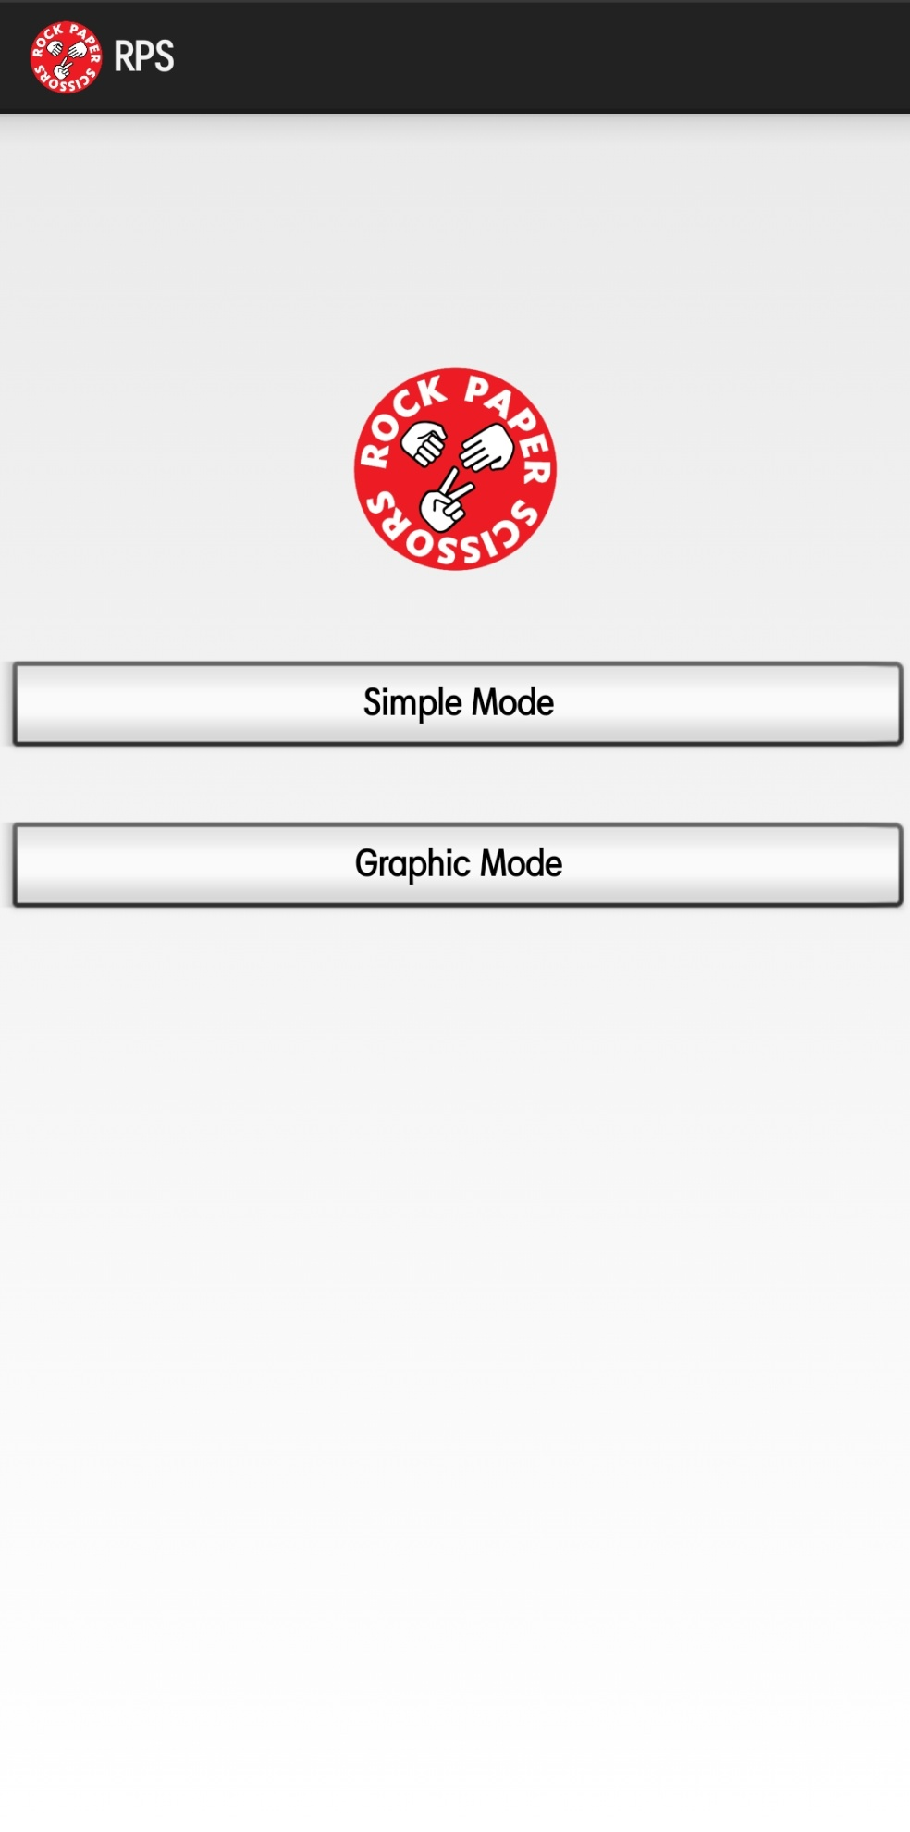

* activity_main.xml

*<?***xml version="1.0" encoding="utf-8"***?>*<**RelativeLayout xmlns:android="http://schemas.android.com/apk/res/android"  
 xmlns:tools="http://schemas.android.com/tools"  
 android:id="@+id/activity_main"  
 android:layout_width="match_parent"  
 android:layout_height="match_parent"**>  
  
 <**TextView  
 android:id="@+id/lblTitle"  
 android:text="----- ROCK PAPER SCISSOR -----"  
 android:textSize="26sp"  
 android:fontFamily="casual"  
 android:textColor="@color/RED"  
 android:layout_width="wrap_content"  
 android:layout_height="wrap_content"** />  
  
 <**TextView  
 android:id="@+id/lblCh"  
 android:text="------------- Your choice -------------"  
 android:textSize="18sp"  
 android:fontFamily="sans-serif"  
 android:layout_width="wrap_content"  
 android:layout_height="wrap_content"  
 android:layout_marginTop="30dp"  
 android:layout_below="@+id/lblTitle"  
 android:layout_alignParentStart="true"** />  
  
 <**Button  
 android:id="@+id/btnRock"  
 android:text="ROCK"  
 android:layout_width="wrap_content"  
 android:layout_height="wrap_content"  
 android:layout_marginTop="30dp"  
 android:layout_below="@+id/lblCh"  
 android:layout_alignParentStart="true"  
 style="@android:style/Widget.Holo.Button"** />  
  
 <**Button  
 android:id="@+id/btnScissor"  
 android:text="SCISSOR"  
 android:layout_width="wrap_content"  
 android:layout_height="wrap_content"  
 android:layout_marginStart="30dp"  
 android:layout_alignBaseline="@+id/btnPaper"  
 android:layout_alignBottom="@+id/btnPaper"  
 android:layout_toEndOf="@+id/btnPaper"** />  
  
 <**Button  
 android:id="@+id/btnPaper"  
 android:text="PAPER"  
 android:layout_width="wrap_content"  
 android:layout_height="wrap_content"  
 android:layout_marginStart="43dp"  
 android:layout_alignBaseline="@+id/btnRock"  
 android:layout_alignBottom="@+id/btnRock"  
 android:layout_toEndOf="@+id/btnRock"  
 style="@android:style/Widget.DeviceDefault.Button.Inset"** />  
  
 <**TextView  
 android:id="@+id/lblPch"  
 android:text="---------- Computer's choice -----------"  
 android:textSize="18sp"  
 android:fontFamily="sans-serif"  
 android:layout_width="wrap_content"  
 android:layout_height="wrap_content"  
 android:layout_marginTop="25dp"  
 android:layout_below="@+id/btnPaper"** />  
  
  
 <**TextView  
 android:id="@+id/lblScore"  
 android:layout_width="wrap_content"  
 android:layout_height="wrap_content"  
 android:layout_below="@+id/lblPChoice"  
 android:layout_alignStart="@+id/lblTitle"  
 android:layout_marginTop="6dp"  
 android:fontFamily="sans-serif"  
 android:text=""  
 android:textSize="18sp"** />  
 <**TextView  
 android:id="@+id/lblPChoice"  
 android:text=""  
 android:textSize="22sp"  
 android:fontFamily="casual"  
 android:textColor="@color/colorAccent"  
 android:layout_width="wrap_content"  
 android:layout_height="wrap_content"  
 android:layout_marginTop="25dp"  
 android:layout_below="@+id/lblPch"  
 android:layout_alignEnd="@+id/btnPaper"** />  
 <**TextView  
 android:id="@+id/lblPC"  
 android:text="----- SCORE ----\n\nPlayer : 0\n\nComputer : 0\n\nDraw : 0\n\nTotal : 0"  
 android:textSize="18sp"  
 android:fontFamily="sans-serif"  
 android:layout_width="wrap_content"  
 android:layout_height="wrap_content"  
 android:layout_marginTop="25dp"  
 android:layout_below="@+id/lblScore"  
 android:layout_alignParentStart="true"  
 android:layout_marginStart="15dp"** />  
 <**TextView  
 android:id="@+id/lblRes"  
 android:text=""  
 android:textSize="26sp"  
 android:textColor="@color/colorAccent"  
 android:fontFamily="casual"  
 android:layout_width="wrap_content"  
 android:layout_height="wrap_content"  
 android:layout_marginTop="40dp"  
 android:layout_below="@+id/lblPC"  
 android:layout_alignParentStart="true"  
 android:layout_marginStart="15dp"** />  
  
 <**TextView  
 android:id="@+id/lblTime"  
 android:layout_width="wrap_content"  
 android:layout_height="wrap_content"  
 android:layout_alignTop="@+id/lblScore"  
 android:layout_alignParentEnd="true"  
 android:layout_marginEnd="29dp"  
 android:textColor="@color/RED"  
 android:textSize="24sp"**/>  
  
  
</**RelativeLayout**>

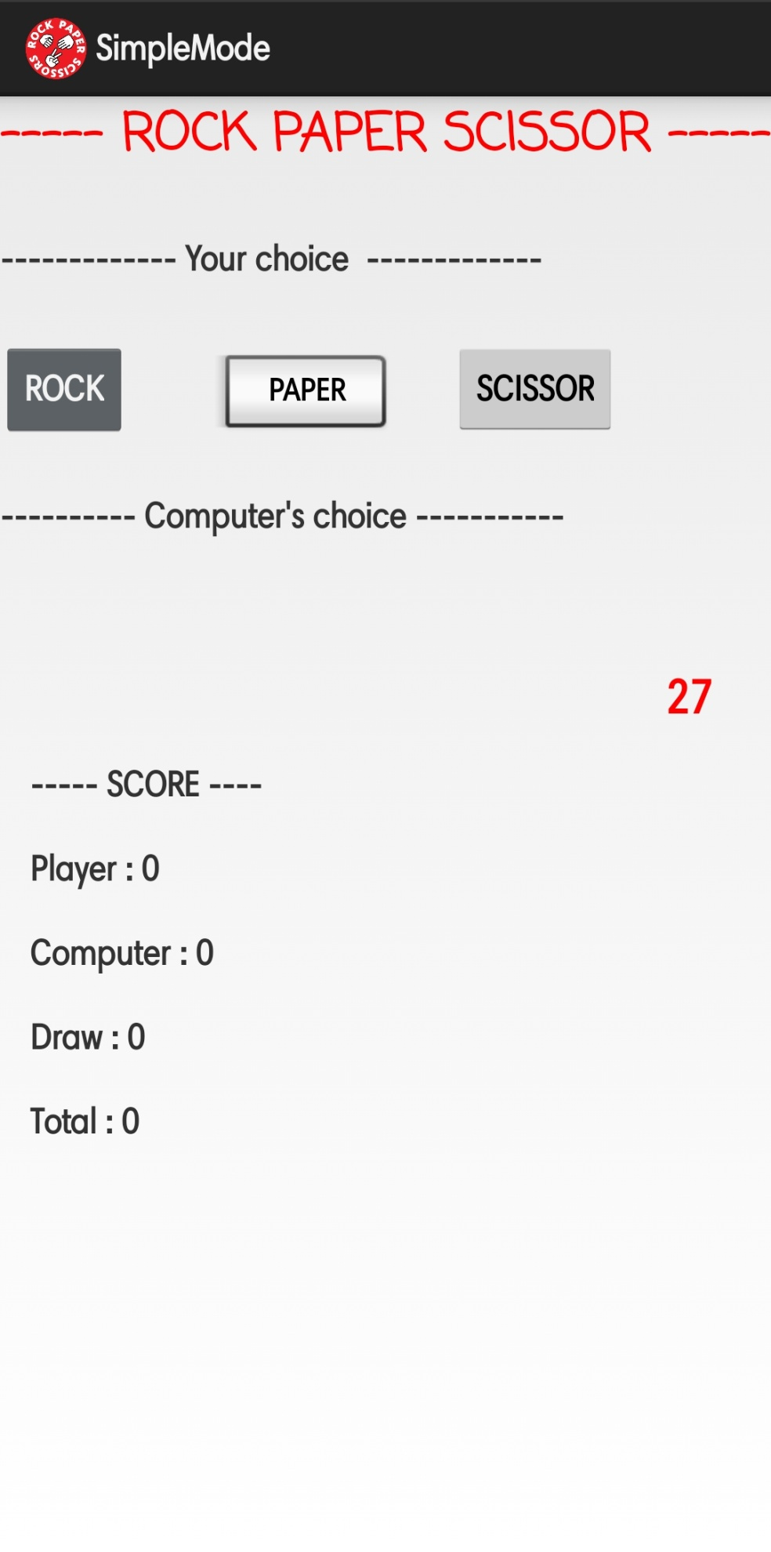

* activity_result.xml

*<?***xml version="1.0" encoding="utf-8"***?>*<**LinearLayout xmlns:android="http://schemas.android.com/apk/res/android"  
 android:layout_width="match_parent"  
 android:layout_height="match_parent"  
 android:orientation="vertical"  
 android:weightSum="2"  
 android:gravity="center"**>  
  
 <**TextView  
 android:id="@+id/lblResFinal"  
 android:layout_width="wrap_content"  
 android:layout_height="3dp"  
 android:layout_weight="1"  
 android:text="TextView"  
 android:textColor="@color/RED"  
 android:textSize="26sp"** />  
 <**ImageView  
 android:id="@+id/btnPlay"  
 android:layout_width="75dp"  
 android:layout_height="75dp"  
 android:src="@drawable/restart"  
 android:rotation="270"**/>  
</**LinearLayout**>

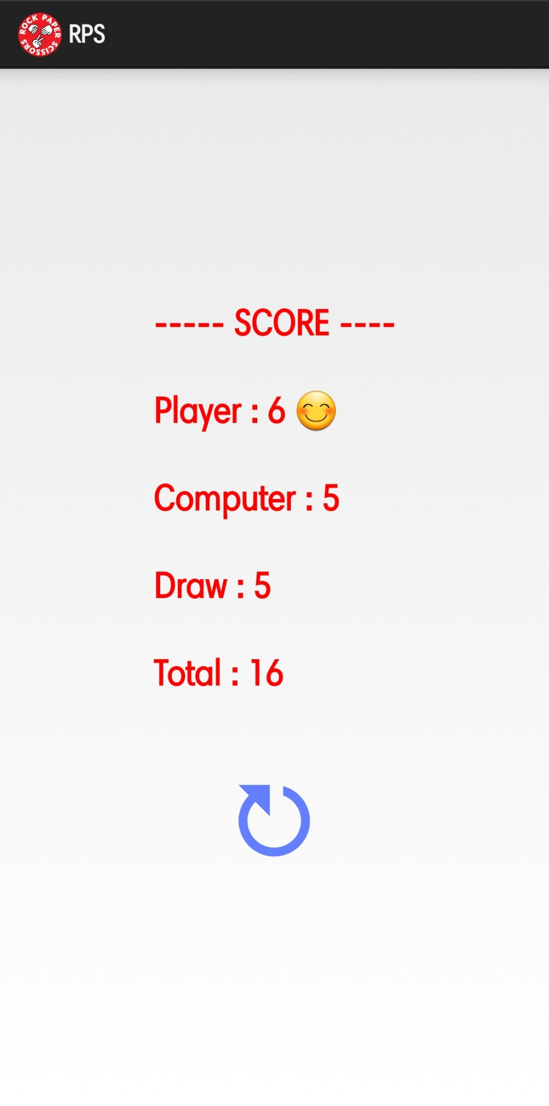

* activity_rpsgraphic.xml
* *<?***xml version="1.0" encoding="utf-8"***?>*<**RelativeLayout xmlns:android="http://schemas.android.com/apk/res/android"  
   xmlns:tools="http://schemas.android.com/tools"  
   android:id="@+id/activity_rpsgraphic"  
   android:layout_width="match_parent"  
   android:layout_height="match_parent"**>  
    
   <**ImageView  
   android:id="@+id/btnRock"  
   android:src="@drawable/dstone"  
   android:layout_width="100dp"  
   android:layout_height="100dp"  
   android:layout_alignTop="@+id/btnPaper"  
   android:layout_alignParentStart="true"** />  
    
   <**ImageView  
   android:id="@+id/btnScissor"  
   android:src="@drawable/dscissor"  
   android:layout_width="100dp"  
   android:layout_height="100dp"  
   android:layout_alignTop="@+id/btnPaper"  
   android:layout_alignParentEnd="true"** />  
    
   <**TextView  
   android:text="ROCK"  
   android:id="@+id/lblbrck"  
   android:fontFamily="casual"  
   android:textSize="22sp"  
   android:layout_width="wrap_content"  
   android:layout_height="wrap_content"  
   android:layout_marginStart="23dp"  
   android:layout_marginTop="10dp"  
   android:layout_below="@+id/btnRock"  
   android:layout_alignParentStart="true"** />  
   <**TextView  
   android:text=" PAPER"  
   android:fontFamily="casual"  
   android:textSize="22sp"  
   android:layout_width="wrap_content"  
   android:layout_height="wrap_content"  
   android:layout_alignBaseline="@+id/lblbrck"  
   android:layout_alignBottom="@+id/lblbrck"  
   android:layout_alignStart="@+id/btnPaper"** />  
   <**TextView  
   android:text="SCISSOR"  
   android:fontFamily="casual"  
   android:textSize="22sp"  
   android:layout_width="wrap_content"  
   android:layout_height="wrap_content"  
   android:layout_below="@+id/btnScissor"  
   android:layout_alignParentEnd="true"  
   android:layout_marginTop="10dp"**/>  
    
    
    
    
    
   <**ImageView  
   android:id="@+id/btnPaper"  
   android:src="@drawable/dpaper"  
   android:layout_width="100dp"  
   android:layout_height="100dp"  
   android:layout_marginTop="69dp"  
   android:layout_below="@+id/btnAI"  
   android:layout_centerHorizontal="true"** />  
    
   <**TextView  
   android:id="@+id/lblAIRes"  
   android:fontFamily="casual"  
   android:textSize="22sp"  
   android:layout_width="wrap_content"  
   android:layout_height="wrap_content"  
   android:layout_marginTop="20dp"  
   android:layout_below="@+id/lblComputer"  
   android:layout_centerHorizontal="true"** />  
    
   <**ImageView  
   android:id="@+id/btnAI"  
   android:layout_width="100dp"  
   android:layout_height="100dp"  
   android:layout_below="@+id/lblAIRes"  
   android:layout_alignStart="@+id/btnPaper"** />  
    
   <**TextView  
   android:id="@+id/lblComputer"  
   android:text="COMPUTER"  
   android:textSize="26sp"  
   android:textColor="@color/RED"  
   android:layout_width="wrap_content"  
   android:layout_height="wrap_content"  
   android:layout_alignParentTop="true"  
   android:layout_alignParentStart="true"** />  
    
   <**TextView  
   android:id="@+id/lblPlayer"  
   android:text="PLAYER"  
   android:layout_width="wrap_content"  
   android:layout_height="wrap_content"  
   android:layout_marginTop="21dp"  
   android:fontFamily="sans-serif"  
   android:textSize="26sp"  
   android:textColor="@color/RED"  
   android:layout_below="@+id/lblbrck"  
   android:layout_alignParentStart="true"** />  
    
   <**TextView  
   android:id="@+id/lblScore"  
   android:text="----- SCORE ----\n\nPlayer : 0\nComputer : 0\nDraw : 0\nTotal : 0"  
   android:layout_width="wrap_content"  
   android:layout_height="wrap_content"  
   android:layout_alignParentTop="true"  
   android:layout_alignParentEnd="true"  
   android:textSize="16sp"**/>  
    
   <**TextView  
   android:id="@+id/lblTime"  
   android:layout_width="wrap_content"  
   android:layout_height="wrap_content"  
   android:layout_alignTop="@+id/lblScore"  
   android:layout_alignParentEnd="true"  
   android:layout_marginTop="438dp"  
   android:layout_marginEnd="39dp"  
   android:text=""  
   android:textColor="@color/RED"  
   android:textSize="24sp"** />  
  </**RelativeLayout**>

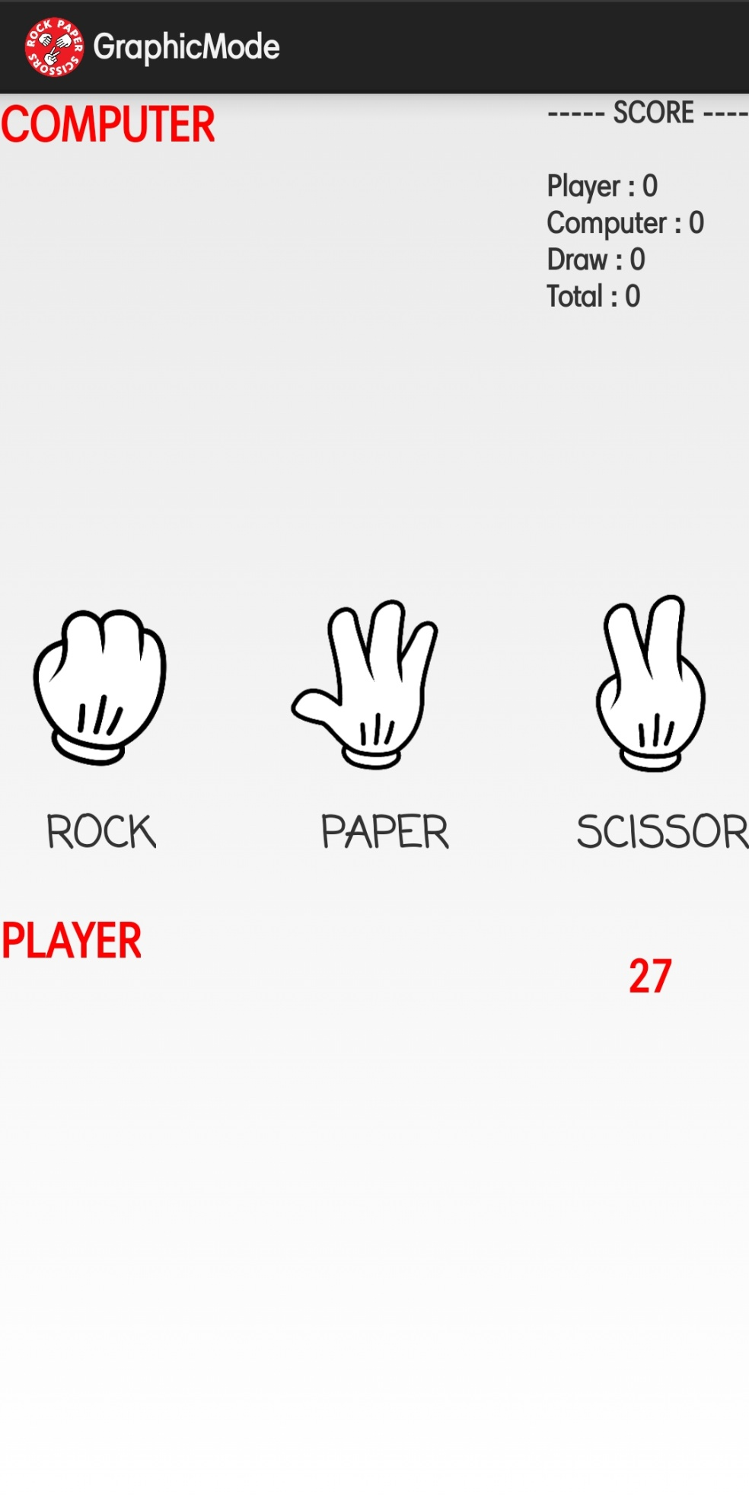

* Values
* colors.xml

*<?***xml version="1.0" encoding="utf-8"***?>*<**resources**>  
 <**color name="colorPrimary"**>#3F51B5</**color**>  
 <**color name="colorPrimaryDark"**>#303F9F</**color**>  
 <**color name="colorAccent"**>#FF4081</**color**>  
 <**color name="RED"**>#FF0000</**color**>  
</**resources**>

* string.xml

<**resources**>  
 <**string name="app_name"**>RPS</**string**>  
 <**string name="action_settings"**>Help</**string**>  
</**resources**>

* style.xml

<**resources**>  
  
 *<!-- Base application theme. -->* <**style name="AppTheme" parent="android:Theme.Holo.Light.DarkActionBar"**>  
 *<!-- Customize your theme here. -->* </**style**>  
  
</**resources**>

* build.gradle
* plugins **{** id **'com.android.application'  
  }**android **{** compileSdk 32  
    
   defaultConfig **{** applicationId **"com.example.amit.rockpaperscissor"** minSdk 25  
   targetSdk 32  
   versionCode 1  
   versionName **"1.0"** testInstrumentationRunner **"androidx.test.runner.AndroidJUnitRunner"  
   }** buildTypes **{** release **{** minifyEnabled **false** proguardFiles getDefaultProguardFile(**'proguard-android-optimize.txt'**), **'proguard-rules.pro'  
   }  
   }** compileOptions **{** sourceCompatibility JavaVersion.***VERSION_1_8*** targetCompatibility JavaVersion.***VERSION_1_8* }  
  }**dependencies **{** implementation **'androidx.appcompat:appcompat:1.4.1'** implementation **'com.google.android.material:material:1.6.0'** implementation **'androidx.constraintlayout:constraintlayout:2.1.4'** testImplementation **'junit:junit:4.13.2'** androidTestImplementation **'androidx.test.ext:junit:1.1.3'** androidTestImplementation **'androidx.test.espresso:espresso-core:3.4.0'  
  }**